1. Configured the system as per prerequisite i.e. installed Eclipse and selenium and configured the web drivers
2. Wrote the basic script to open the website, check the landing page and return the URL and title of the page. 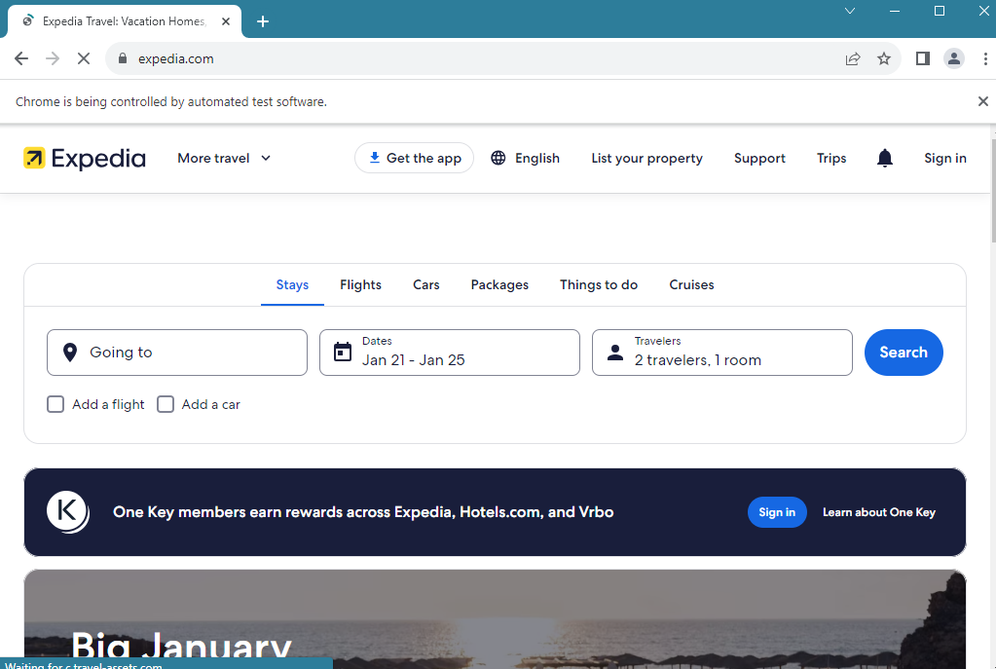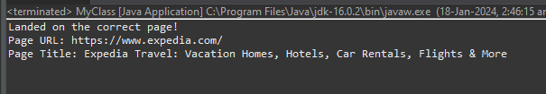
3. Click on flights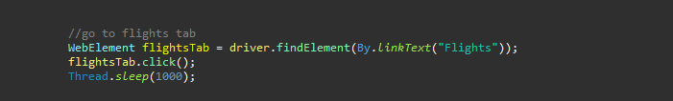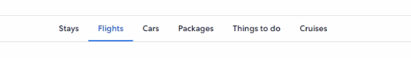
4. Click on oneway

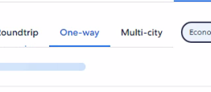

1. Enter source city kolkata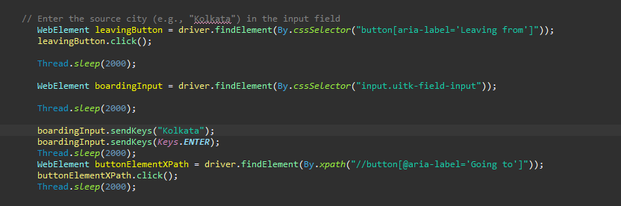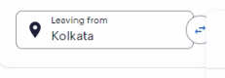
2. Enter destination city hyderabad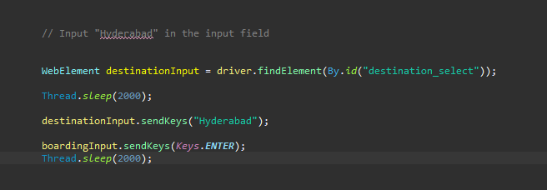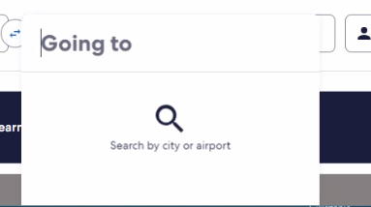
3. Select the date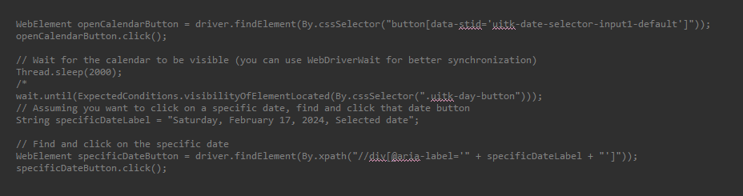
4. Edit Passengers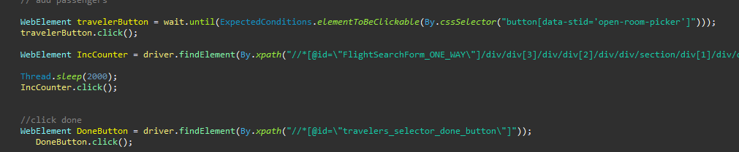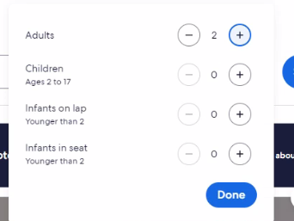
5. Click on search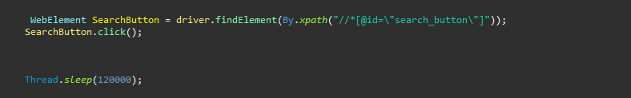
6. Click on first Flight

